**Guide to downloading and installing Oracle 11g on your own Windows Pc**

1. Download Oracle 11g Express Edition from Oracle Technical Network - Install– follow the default prompts
2. Once installed, from Start Menu -> All Programs -> Oracle 11g Express Edition Choose Run SQL Command

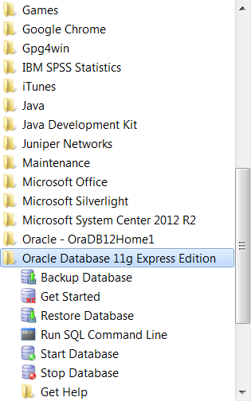

1. Connect as SYSDBA - the password is SYSDBA

Create a user with the username and password required

Grant the user privilege

See screen below

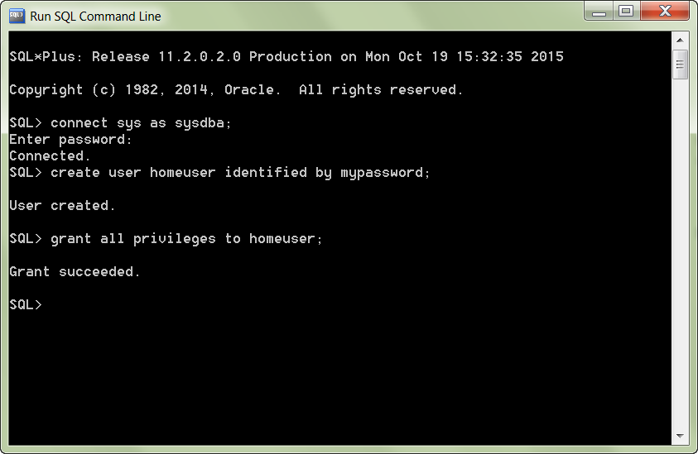



The username

The password

1. Download and install SQL Developer from Oracle Technical network (if you need to)

Create a Connection to your local Oracle instance using the username and password created

